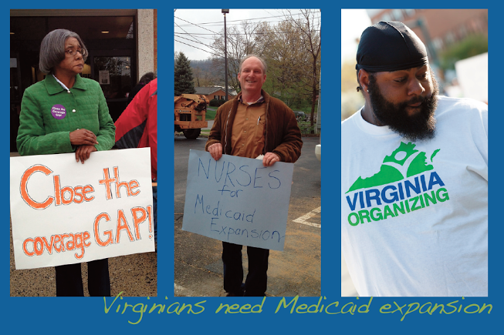

***Vigil for the Least of These***

**What**: Silent vigil for Medicaid Expansion calling on Speaker Bill Howell to expand medical coverage to 400,000 Virginians who need healthcare. Despite the General Assembly’s decision last week, we intend to keep up the pressure by raising our voices in support of Medicaid Expansion!

**When**: Sunday, June 29th, 9am-10:30am

**Where**: Meet at the parking lot in front of Hard Times Café, 314 Jefferson Davis Highway, Fredericksburg, VA, 22401. We will gather, write messages to Speaker Howell, hear from speakers, and then those that want to participate will march along the Rt. 1 Bridge where we will hold a vigil for 15-20 minutes.

Following the vigil, those who are willing and able will march to Speaker Howell’s office to deliver a coffin filled with our messages to Howell. Posters with messages of love and care for our fellow Virginians will be provided.

 

Questions? Contact Addie Alexander, 434-249-4058, [addie@virginia-organizing.org](mailto:addie@virginia-organizing.org)

Please let NETWORK Volunteer Barbara Hazelett know if you attend: bhazelett@networklobby.org