

Dear UUSJ Board Member and Alternates:
At the June 22nd Special Board meeting, we identified a “Core Group” of people to continue or momentum and starting with focus on our governance structure as identified as by the Board as a starting point. The Core Group membership is made up of Executive Committee, Jim Alcauskas, Board member from BRUU, and David Strauss, UUSJ member from Rockville and member of our Immigration Steering Committee.
We had a slow start to forming the group. People were enjoying the summer, but with the able nudging and initiation from John Gubbings we moved forward to apply for a grant to provide us with the funds needed to put us on the path towards implementation of our vision and hiring needed staff and/or consultants.
The Core Group submitted on September 15th a grant application to the Fund for UU Social Responsibility of the UU Funding Program (Veatch supported) asking for $20,000, to carry out the work we began to identify at our June 22nd Special Board meeting. We will know if our grant was successful toward the end of November, and if so, the money would be made available in January 2015. Such grants are for a program of a year or less.
The Narrative part of the application is a wonderful statement of UUSJ’s recent history, the rationale for the changes being made, our best ideas about how to move forward from where we are, and where we want to go. Please read the attached narrative of the application so you understand fully the context for the coming decisions the UUSJ Board needs to make. Reading it is a prerequisite for us all to be on the same page as we move forward into a new UUSJ era.
We will make available a few copies of the full application at our October 4th board meeting.
See you on October 4th at 5:30 pm if not before.
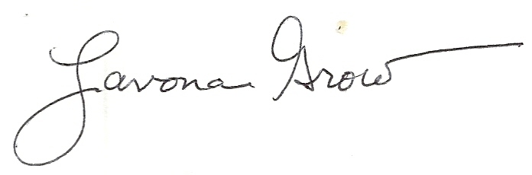
Lavona Grow,
Board Chair

