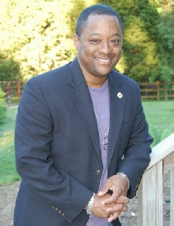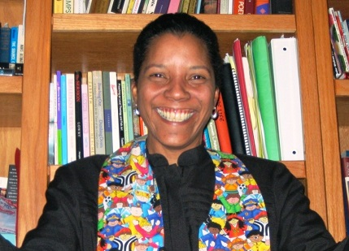

Transforming Our Faith Communities   
the Journeys of Ministers of Color

*A Conversation with Rev. John Crestwell Rev. Dr. Leon Dunkley   
Rev. Abhi Janamanchi Rev. Archene Turner*

Goodloe Memorial

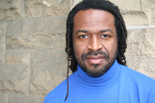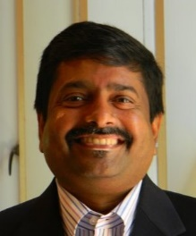

Goodloe Memorial Unitarian Universalist Congregation  
1520C Pointer Ridge Place Bowie 20716  
Saturday April 25, 2015 4 pm – 7 pm